**Thermodynamic Advantage of Transient Wave Dynamics in Hierarchical Decision Architectures**

Oleg Dolgikh

**Graphical Abstract (optional)**

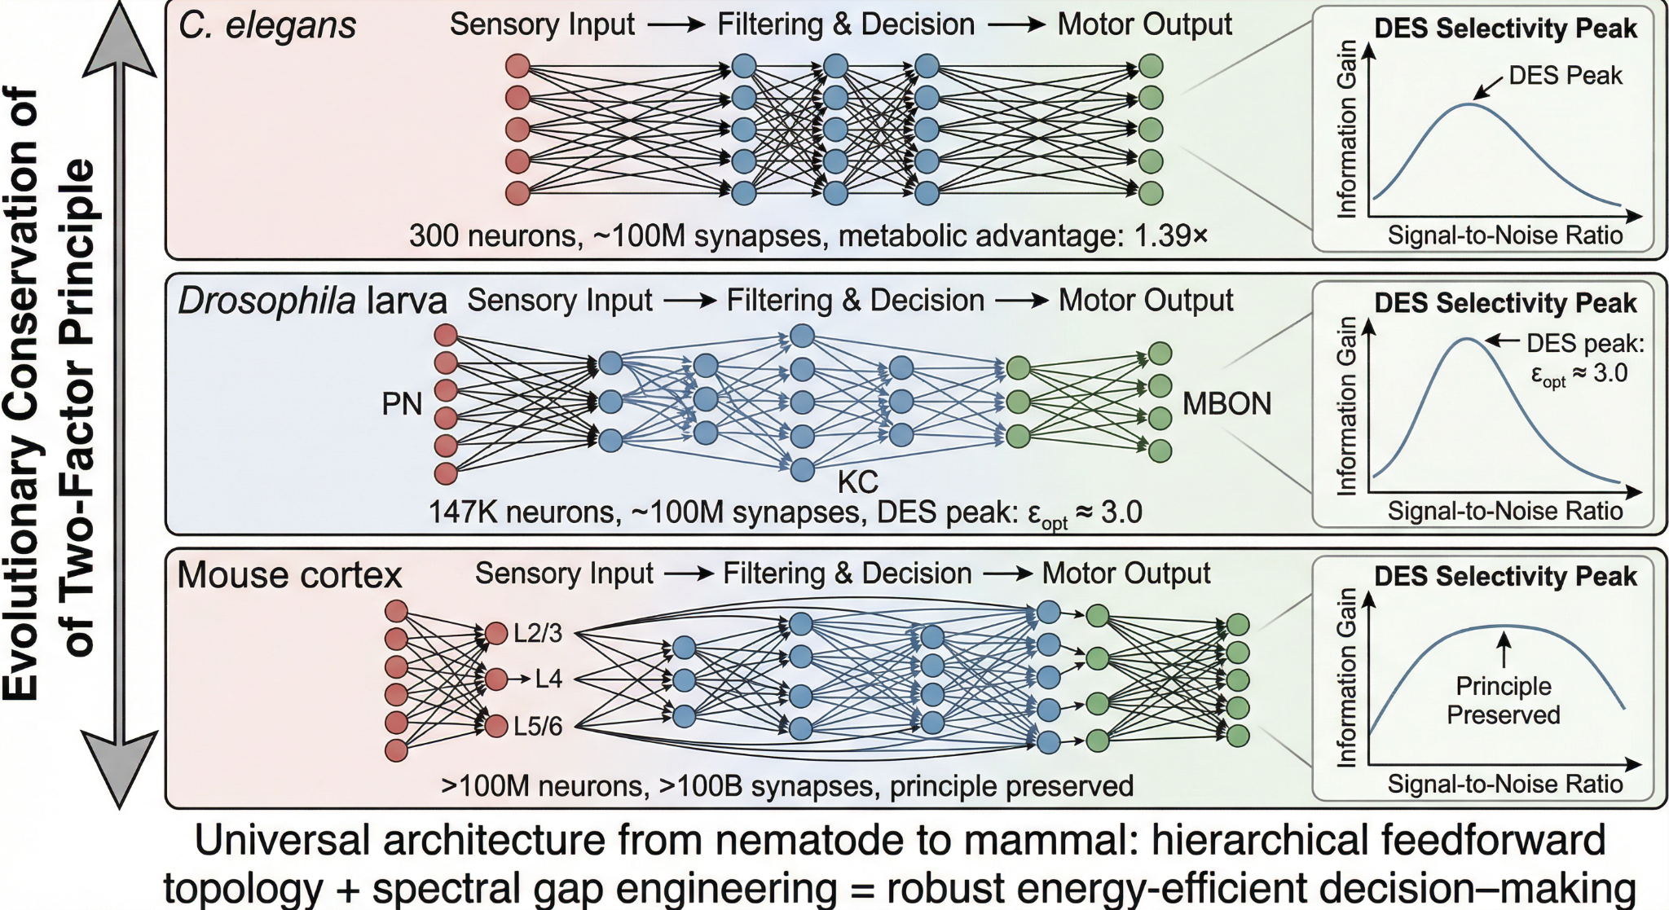

Graphical Abstract. Evolutionary conservation of a two-stage decision motif (Stage-I filtering/netting → Stage-II decision/motor commitment) across three neural scales. The schematic summarizes the key empirical signatures: a metabolic advantage in C. elegans (1.39× at low T_env) and a Disorder-Enhanced Selectivity (DES) peak in Drosophila at moderate disorder (ε≈3), with the principle preserved in a mouse cortex proxy.

# Abstract

Biological agents face an energy–information bottleneck: inference requires rapid exploration of large hypothesis spaces, yet high‑gain spiking is metabolically expensive. We propose a two‑stage decision architecture in which Stage‑I is modeled as low‑amplitude wave‑like exploration on the connectome that prunes hypotheses (“netting”), followed by Stage‑II spiking fixation. Stage‑I is implemented with a Gorini–Kossakowski–Sudarshan–Lindblad (GKSL) open‑system proxy interpolating between coherent transport and diffusion via a dephasing rate κ; diagonal disorder ε models stress‑induced heterogeneity of excitability. Across three substrates—C. elegans, a Drosophila larva mushroom‑body decision motif, and a mouse cortex proxy—we observe Disorder‑Enhanced Selectivity (DES): moderate disorder improves decision selectivity and information‑per‑cost under partially coherent dynamics. In C. elegans at low T_env, the wave proxy achieves 1.39× higher target absorption than a thermal baseline. In Drosophila, DES is strongest in the native topology and is attenuated by degree‑preserving rewiring, indicating a topology×coherence interaction. DES provides a candidate network‑level substrate for inverted‑U stress–performance phenomenology and yields falsifiable predictions for temperature and anesthesia scans.

Keywords: coherent transport; open‑system dynamics; noise‑assisted transport; connectome; metabolic cost; decision selectivity; Yerkes–Dodson.

# 1. Introduction

Neural computation is constrained by thermodynamics. Action potentials and synaptic transmission dominate the energetic budget of grey matter, so “more computation” is not free: search that relies on repeated spiking updates can become metabolically prohibitive at scale [2,3]. This motivates an energy–information bottleneck framing: as hypothesis spaces grow (more states, more routes, more contingencies), purely diffusive exploration can become prohibitively slow—especially on bottlenecked or hierarchically structured graphs—while accelerating search by increasing spiking activity risks exceeding available metabolic throughput.

The Free‑Energy Principle (FEP) casts perception and action as approximate inference in which agents minimize a variational free energy bound on surprise [1]. Classical attractor networks (e.g., Hopfield networks) show how recurrent connectivity can stabilize memories and decisions [5], but attractor relaxation can be slow and each update in a spiking substrate carries energetic cost. In another domain, quantum and classical wave transport in noisy, disordered media has revealed a complementary principle: environmental noise can increase transport efficiency by preventing localization and enabling effective exploration (ENAQT and related mechanisms) [7–10].

We propose that these insights can be unified as an architectural principle rather than a claim about microscopic substrate. Specifically, we hypothesize a two‑stage decision pipeline: Stage‑I is modeled as low‑amplitude, wave‑like dynamics that rapidly explores and prunes hypotheses on the structural connectome (cheap search), and Stage‑II commits via sparse, high‑gain spiking fixation (expensive commitment). We call this principle Coherent‑Resonant Netting (CRN). We do not assume that the brain is a quantum computer. Instead, we use GKSL dynamics as a mechanistic proxy for any transient wave process (quantum or classical) with tunable dephasing and disorder, and test whether such dynamics provide (i) improved selectivity and (ii) improved information per unit cost on real connectomes. We term the key inverted‑U signature Disorder‑Enhanced Selectivity (DES), by analogy to noise‑assisted transport phenomena in disordered media (e.g., ENAQT).

# 2. The CRN Framework

## 2.1. Two‑Factor mechanism: coherence × topology

CRN predicts that decision efficiency depends on two coupled factors. Factor‑I (“Coherence”) quantifies the extent to which propagation involves superposition rather than purely stochastic hopping. Factor‑II (“Topology”) is the structural constraint imposed by the connectome, which shapes interference, localization, and spectral gaps. In this view the native connectome acts as an interferometric mask: it determines where interference is constructive vs. destructive, and thus whether transport concentrates on a target subspace (useful hypotheses/routes) or leaks to distractors.

We model Stage‑I transport on a graph G(V,E) using a GKSL master equation for a density matrix ρ(t): dρ/dt = −i[H,ρ] + κ·𝓓_deph(ρ) + 𝓛_sink(ρ). Here H encodes coherent coupling derived from graph adjacency, κ controls dephasing toward classical diffusion, and 𝓛_sink implements absorbing channels attached to target and distractor node sets. This formalism (GKSL/Lindblad) provides a continuous interpolation between coherent quantum‑walk dynamics (κ→0) and classical random walks (κ→∞) [11–14].

Diagonal disorder is introduced as node‑energy heterogeneity H_ii ~ U[−ε,+ε]. We interpret ε as a proxy for metabolic stress: under stress, resting potentials, excitability thresholds and synaptic gains become more heterogeneous, increasing the effective ‘energetic roughness’ of the state space. In disordered media, heterogeneity can induce Anderson localization—suppression of transport along many paths [6]. In networked decision motifs, this suppression can be constructive if it damps broad, high‑entropy distractor pathways more strongly than the target route, producing Disorder‑Enhanced Selectivity (DES).

## 2.2. Two‑stage architecture: Stage‑I netting and Stage‑II fixation

CRN is an architectural hypothesis about how biological agents allocate energy across computation. It distinguishes two phases of decision processing that operate on different cost scales and may be implemented by different biophysical mechanisms.

Stage‑I (“netting”, pre‑selection) is a low‑amplitude, subthreshold regime that propagates graded activity over the structural graph before global spiking commitment. Its computational role is to rapidly concentrate probability mass on a small subset of candidate hypotheses (targets) while suppressing broad, high‑entropy alternatives (distractors). In this work Stage‑I is simulated explicitly: GKSL dynamics produces absorption probabilities P_sink_T(t) and P_sink_D(t) at target and distractor sinks, and their endpoints define Selectivity_end and coverage_end.

Stage‑II (“fixation”, commitment) is a high‑gain, metabolically expensive regime that turns the filtered Stage‑I outcome into a stable belief, memory or action. Stage‑II includes spiking broadcast, attractor stabilization, synaptic tagging and reinforcement, and downstream motor commitment. In Stage‑II, classical attractor dynamics are advantageous: once Stage‑I has pruned the hypothesis space, recurrent networks can settle quickly within a reduced basin of candidates, lowering the number of expensive spiking updates required for stable commitment [5].

A simple energy accounting clarifies the advantage. Let E_I be the energy cost of Stage‑I netting and E_II the marginal cost of one Stage‑II commitment event (or a unit of high‑gain spiking time). If Stage‑I reduces the expected number or duration of commitments from N_commit to N_commit′, the net gain is ΔE ≈ (N_commit − N_commit′)·E_II − E_I. CRN predicts a benefit when ΔE>0. This turns the ‘wave’ question into a testable inequality: Stage‑I is worth it only if it meaningfully reduces downstream spiking cost.

The two‑stage view helps reconcile competing functional demands. For feed‑forward routing problems (deliver a signal to a specific downstream target), high permeability can be useful: wave‑like dynamics can overcome barriers and speed routing through noisy media. For recurrent associative memory, however, high permeability can be harmful: if activity leaks too easily across weak inter‑engram edges, false recall increases (a permeability paradox). CRN therefore predicts a division of labor: wave‑like netting is useful for search‑and‑route motifs, while strong confinement and inhibitory gating are beneficial for stable attractor storage.

Finally, CRN is compatible with cognitome‑level views in which cognition is organized not only by the static connectome but by a higher‑order hypernetwork of cognitive elements and their integration dynamics [17]. In CRN terms, Stage‑I implements a fast ‘proposal generator’ constrained by the structural interferometric mask of the connectome, while Stage‑II selects and stabilizes a specific integrated configuration. The central empirical claim is then explicit: if native topology encodes useful interference structure, DES should be strongest in the native connectome and should weaken under topology‑destroying controls.

## 2.3. Classical mimicry and mechanistic neutrality

A common concern is that GKSL implies a quantum substrate. We stress that this is not required for the architectural claim. Any linear wave equation with tunable damping and phase randomization can exhibit interference and localization phenomena, including inverted‑U regimes. GKSL is used here because it exposes two explicit control parameters (κ for dephasing and ε for disorder) and admits clear limiting baselines (coherent vs classical diffusion). Thus, failure of CRN predictions would falsify the architecture regardless of whether the underlying wave substrate is quantum or classical.

# 3. Methods

GKSL/Lindblad dynamics is used here as a functional proxy for open‑system wave evolution with tunable dephasing and disorder; it does not imply or require microscopic quantum coherence in neural tissue.

## 3.1. Decision benchmark and metrics

For each substrate we define a target set T (desired hypothesis/route) and a distractor set D (competing routes). Absorbing sinks attached to T and D yield endpoint probabilities P_sink_T_end and P_sink_D_end. We report Selectivity_end = P_sink_T_end / (P_sink_D_end + δ) and coverage_end = P_sink_T_end + P_sink_D_end, with δ a small stabilizer. To connect to energetic arguments, we also evaluate energy‑aware objectives: Utility = P_sink_T_end − λ·P_sink_D_end and InfoPerCost = Utility / Cost, where Cost is proportional to integrated dissipation (proxy for throughput/energy). Parameter sweeps over κ and ε identify regimes that maximize Selectivity_end or InfoPerCost.

## 3.2. Substrates and rationale

C. elegans provides a uniquely complete connectome at single‑synapse resolution and is therefore a minimal, high‑credibility testbed for topology‑dependent transport [16]. Its small size enables exhaustive parameter sweeps and mechanistic interpretation.

Drosophila larva mushroom body (MB) provides a canonical hierarchical decision motif: sparse expansion (PN→KC) followed by convergent readout (KC→MBON). It is an archetype for hypothesis selection in olfactory learning. We use the full larval connectome reported by Winding et al. (Science, 2023) and extract an MB subgraph for benchmarking [18].

Mouse cortex is included to test scalability and to illustrate the permeability paradox in recurrent motifs. Because full cortical micro‑connectomes at required resolution are not yet available, we use a controlled stochastic block model proxy informed by known mesoscale connectivity constraints [22].

## 3.3. Controls (competitors) and surrogate networks

To isolate topology dependence, we generate degree‑preserving, type‑aware rewired surrogates (Maslov–Sneppen randomization) [19] and compare them to targeted pathway lesioning (dropping a fixed fraction of KC→MBON edges). As dynamical competitors, we include classical random walk (CRW) and thermally activated hopping (CRW_thermal) with Metropolis rates. Effects are evaluated over trial ensembles and (where applicable) over surrogate ensembles.

# 4. Results

## 4.1. Architecture overview

Figure 1 provides the conceptual anchor for CRN. Stage‑I netting is modeled as open‑system wave transport on the connectome with tunable dephasing κ and disorder ε; Stage‑II spiking fixation commits to the filtered outcome. CRN predicts a Two‑Factor dependence (coherence × topology): native topology acts as an interferometric mask, and moderate disorder can yield a Disorder‑Enhanced Selectivity (DES) peak by suppressing distractor pathways more than the target route.

Figure 1. Two‑Factor mechanism in the Coherent‑Resonant Netting (CRN) framework. Stage‑I is simulated with a GKSL open‑system proxy (top): coherent coupling on the connectome plus dephasing κ and absorbing sinks. Factor‑I (coherence/superposition) and Factor‑II (spectral topology) combine to produce a DES profile (bottom): intermediate disorder ε can maximize Selectivity_end when the topology supports constructive localization of target pathways.

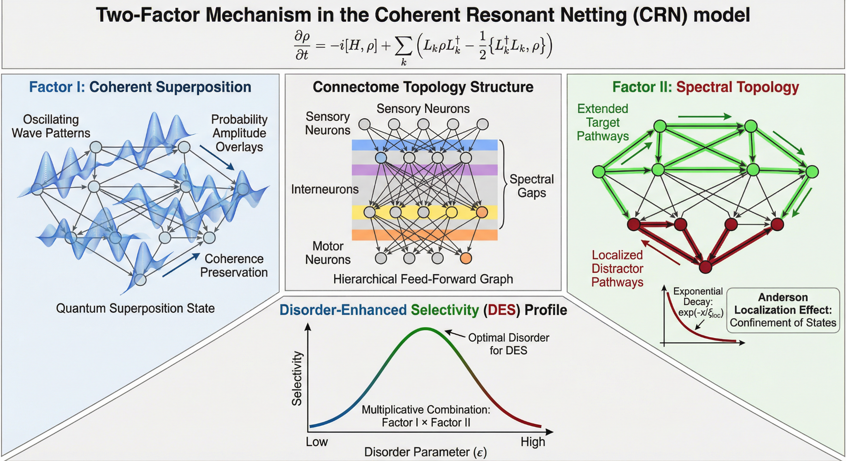

## 4.2. Cross‑substrate evidence for Disorder‑Enhanced Selectivity

Across C. elegans, Drosophila larva MB, and a mouse cortex proxy, we observe that moderate disorder can improve selectivity and/or information‑per‑cost under partially coherent dynamics, while classical baselines typically show monotone degradation or weak sensitivity. Figure 2 summarizes the cross‑substrate patterns.

In the C. elegans connectome benchmark, the advantage of Stage‑I wave‑like transport is most pronounced in a low‑T_env (T_env=0.1) ‘metabolic stress’ regime where classical thermal hopping is barrier‑limited. Under matched conditions, the wave proxy reaches a maximum target‑sink absorption P_max=0.997 versus P_max=0.716 for the thermal baseline, a 1.39× (39%) improvement (Fig. 2, left panel). This provides a quantitative thermodynamic motivation for Stage‑I: when spiking‑equivalent updates are costly, transient wave dynamics can deliver more useful throughput per unit cost.

Figure 2. Disorder‑Enhanced Selectivity (DES) across neural scales. Selectivity S versus disorder ε for three substrates: C. elegans touch circuit (left), Drosophila larva mushroom body (middle), and a mouse‑cortex proxy (right). Points show mean ± 95% CI across trials (and surrogate ensembles where applicable); the solid curve is an inverted‑U fit. Dashed vertical lines indicate ε_opt estimated from the sweep. The Drosophila panel highlights a pronounced DES peak near ε≈3 in the native topology.

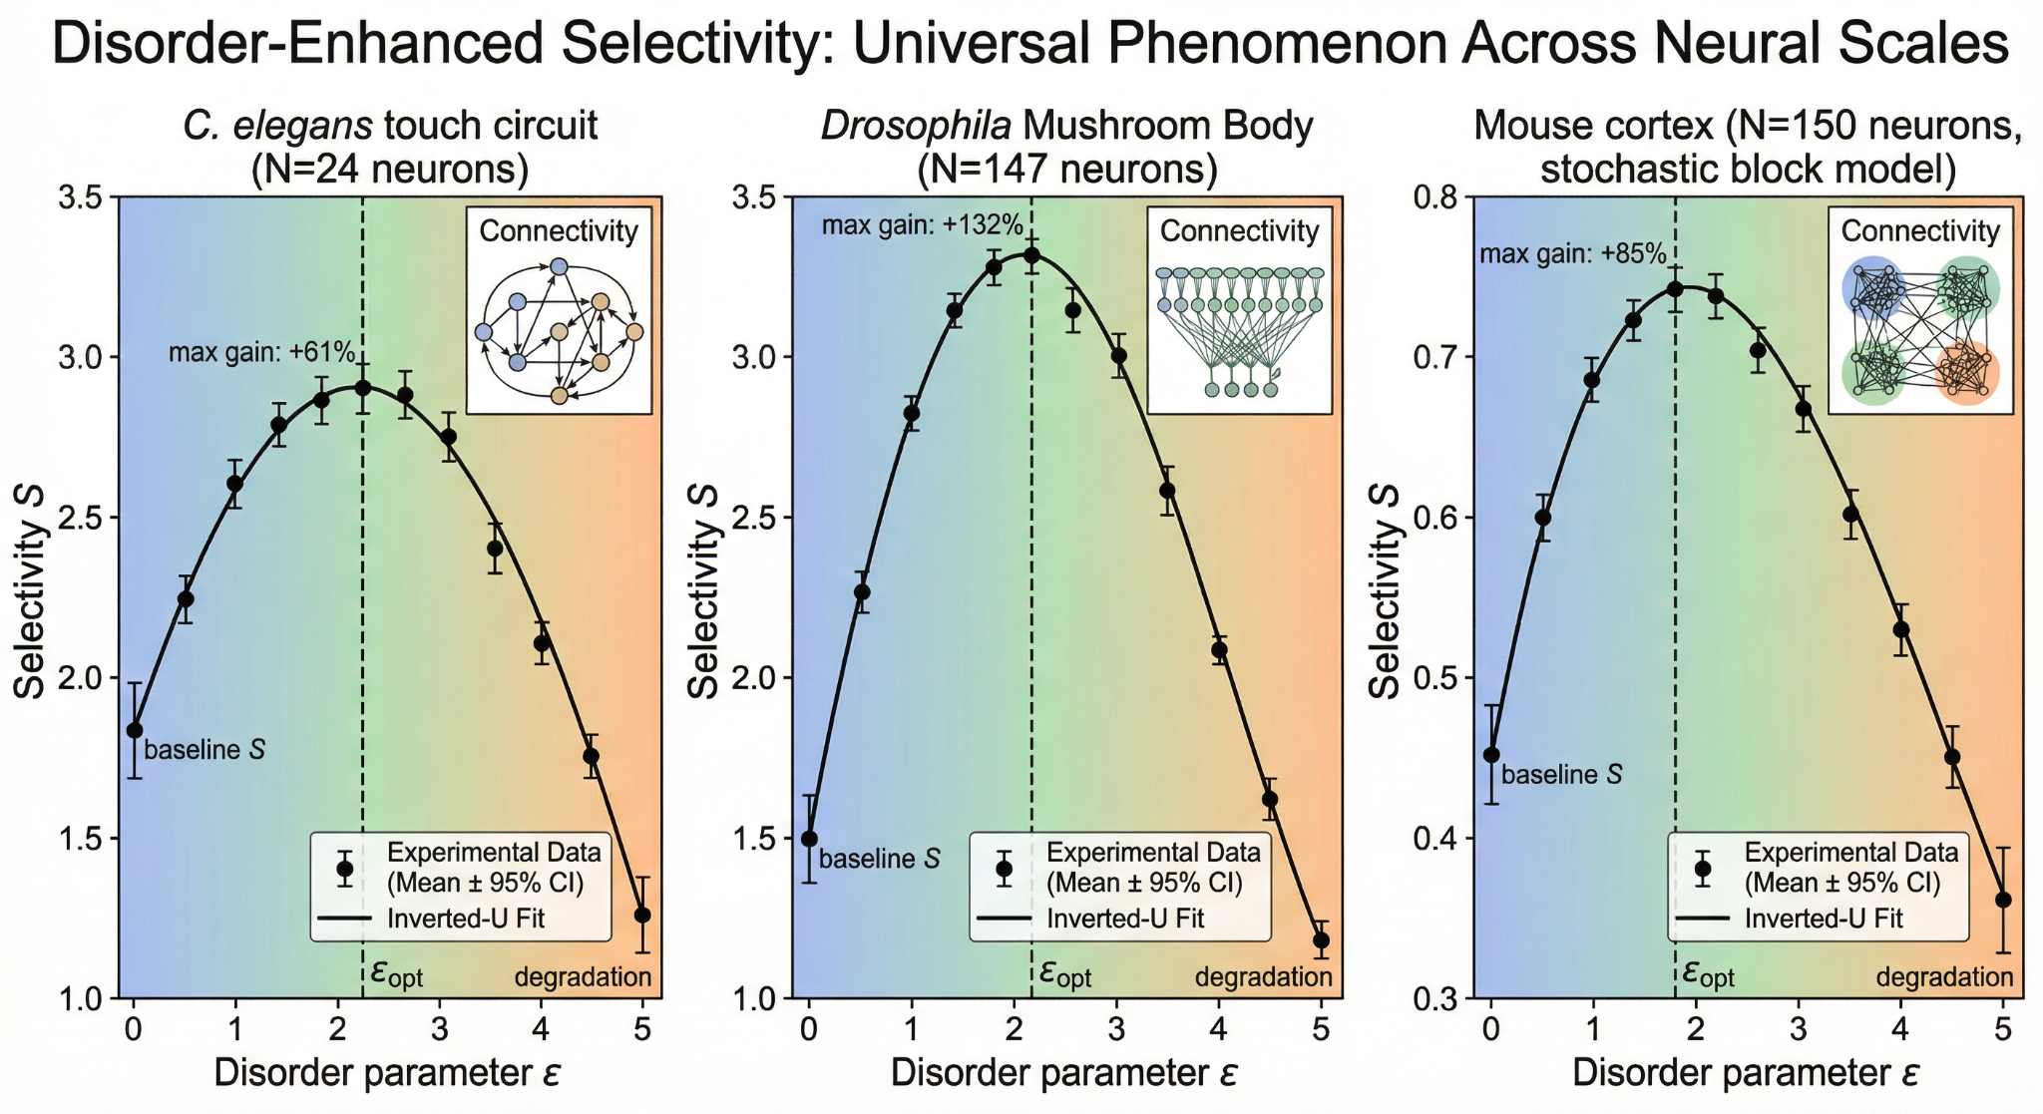

## 4.3. Drosophila larva MB: a topology‑ and coherence‑dependent DES peak

In the Drosophila larva mushroom‑body connectome, Selectivity_end exhibits a robust non‑monotonic dependence on disorder ε at low dephasing (κ=0.001). In the native (‘original’) topology, mean Selectivity_end increases from 1.18 at ε=0 to 2.66 at ε≈3, then decreases at ε=5 (Tables S8‑4; Fig. 3). Two‑way ANOVA confirms significant main effects of VARIANT and EPSILON on Selectivity_end (F=44.70 and 31.12, respectively; p≪0.001) and a significant cell effect across (VARIANT×EPSILON) combinations (F=20.53; p≪0.001), consistent with an interaction‑like dependence rather than a single‑parameter trend (Table 1).

The DES peak is architecture‑dependent. Degree‑preserving rewiring markedly reduces the disorder benefit (bootstrap Δ(ε=3−0)=+0.162 [0.056,0.274]), whereas the native topology shows a much larger DES (Δ=+1.489 [0.249,3.355]). Target‑pathway lesioning attenuates but does not eliminate DES (Δ=+1.102 [0.830,1.398]). Between‑variant bootstraps confirm that DES in the native topology exceeds rewired surrogates (ΔDES=+1.328 [0.069,3.232], p<0.001), supporting the claim that the effect is not explained by degree distribution alone (Tables S8‑2–S8‑3). The disappearance of the DES peak in rewired networks serves as a negative control, demonstrating that coherence alone is insufficient; the native connectome provides a necessary interferometric mask that shapes constructive interference and localization.

Interpreting ε as a proxy for metabolic stress (increased heterogeneity of excitability/energy levels), these results are consistent with an inverted‑U relationship between stress and benchmark selectivity. In the model, moderate disorder preferentially suppresses high‑entropy distractor pathways (a localization‑like filtering effect), improving Selectivity_end, whereas excessive disorder reduces coverage_end and degrades performance. We suggest that DES offers a candidate network‑level substrate for the phenomenology of the Yerkes–Dodson law, without claiming a one‑to‑one identity between this benchmark and organism‑level cognitive performance under stress.

### Table 1. Two‑way ANOVA (kappa=0.001) on Drosophila MB architecture sweep.

|  |  |  |  |  |  |
| --- | --- | --- | --- | --- | --- |
| Metric | Effect | F | df1 | df2 | p_value |
| Selectivity_end | VARIANT | 44.70 | 2 | 4097 | 6.25e-20 |
| Selectivity_end | EPSILON | 31.12 | 4 | 4095 | 1.45e-25 |
| Selectivity_end | ALL_CELLS | 20.53 | 14 | 4085 | 4.16e-51 |
| coverage_end | VARIANT | 14.33 | 2 | 4097 | 6.28e-07 |
| coverage_end | EPSILON | 2906.98 | 4 | 4095 | <1e-300 |
| coverage_end | ALL_CELLS | 932.38 | 14 | 4085 | <1e-300 |

## 4.4. Architecture dependence across κ

Figure 3 summarizes the Two‑Factor prediction: DES is strongest at low κ in the native topology and is attenuated by rewiring. At higher κ (more classical diffusion), the non‑monotonic DES peak weakens and selectivity trends become more monotone.

Figure 3. Architecture dependence of DES in Drosophila larva mushroom body. (A) κ=0.001 (low dephasing) and (B) κ=1.0 (higher dephasing). Selectivity is shown as ratio‑of‑means across replicate means for original, rewired_type and lesion_KC_MBON. Non‑monotonic DES is strongest in the native topology under low κ and is attenuated by rewiring.

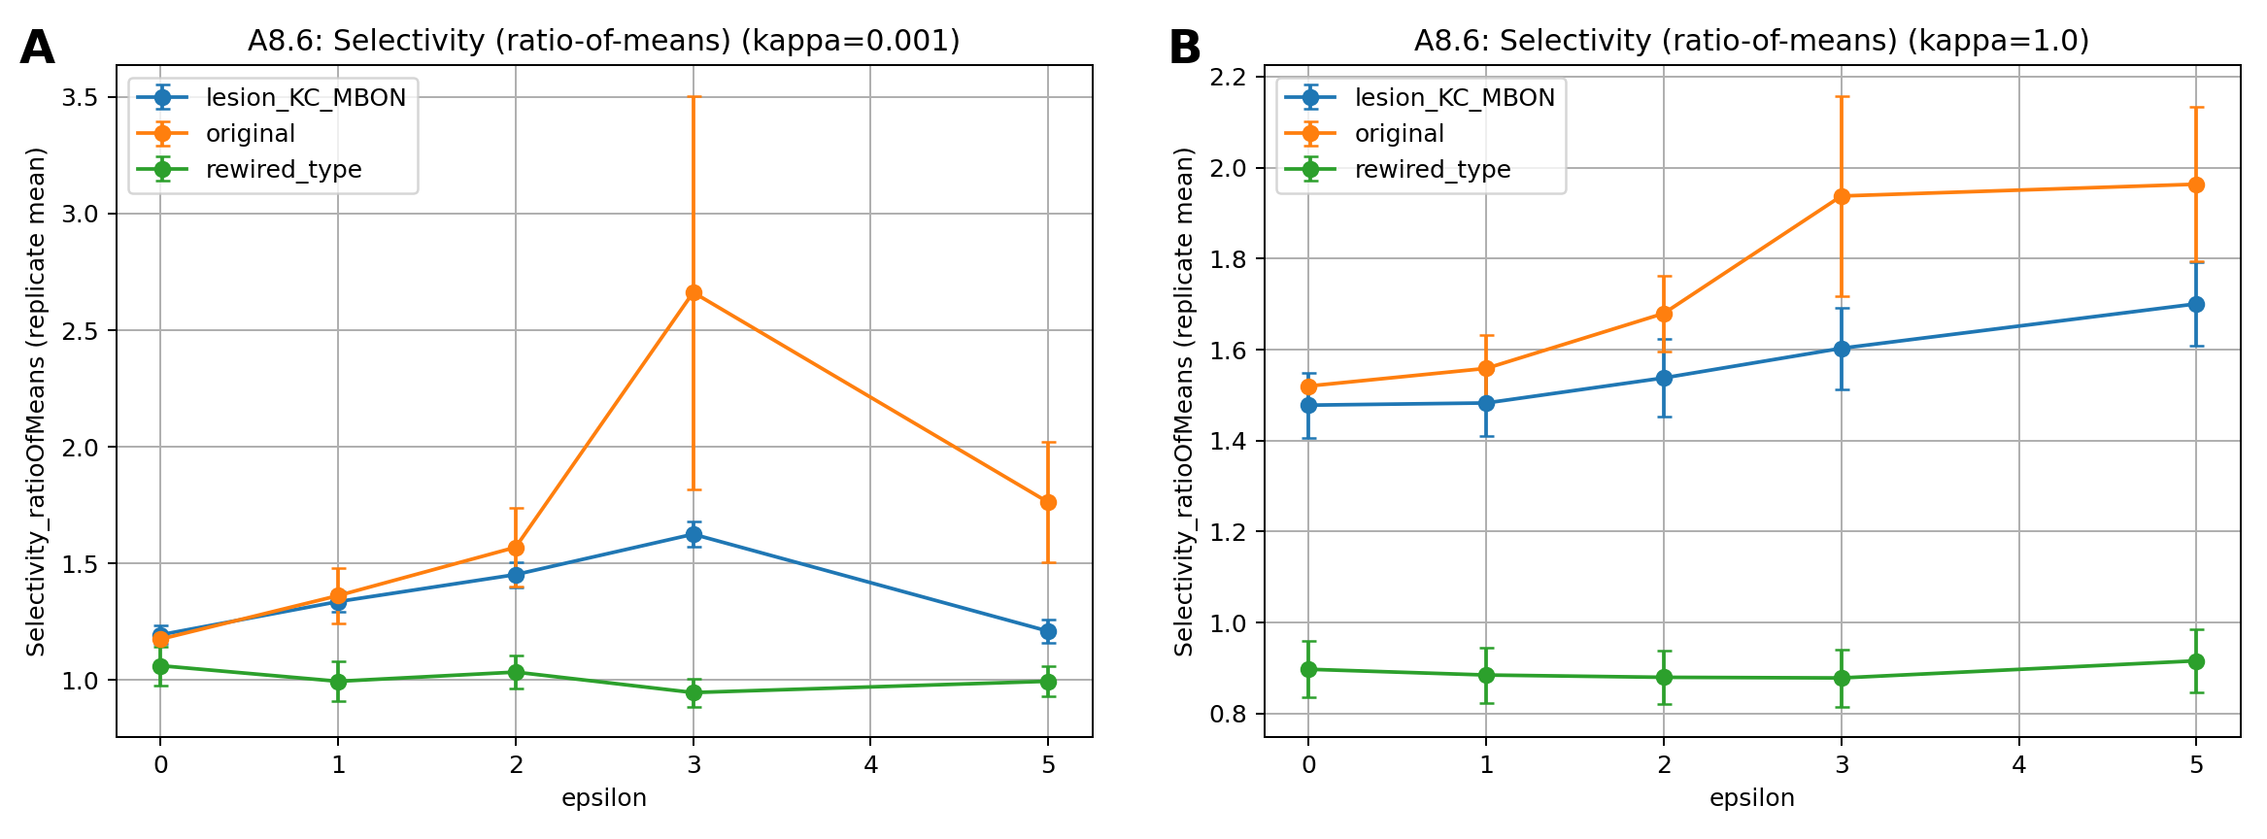

To complement mean Selectivity_end, we compute an outcome metric P_good = Pr(Selectivity_end > 2 and P_sink_T_end > pT_min), capturing the probability of a ‘good run’ rather than average performance. P_good shows an intermediate‑ε enhancement in the native and lesion variants and is strongly suppressed by rewiring (Fig. S1).

*Figure S1. Probability‑of‑good‑run P_good vs disorder ε at κ=0.001 (Drosophila MB).*

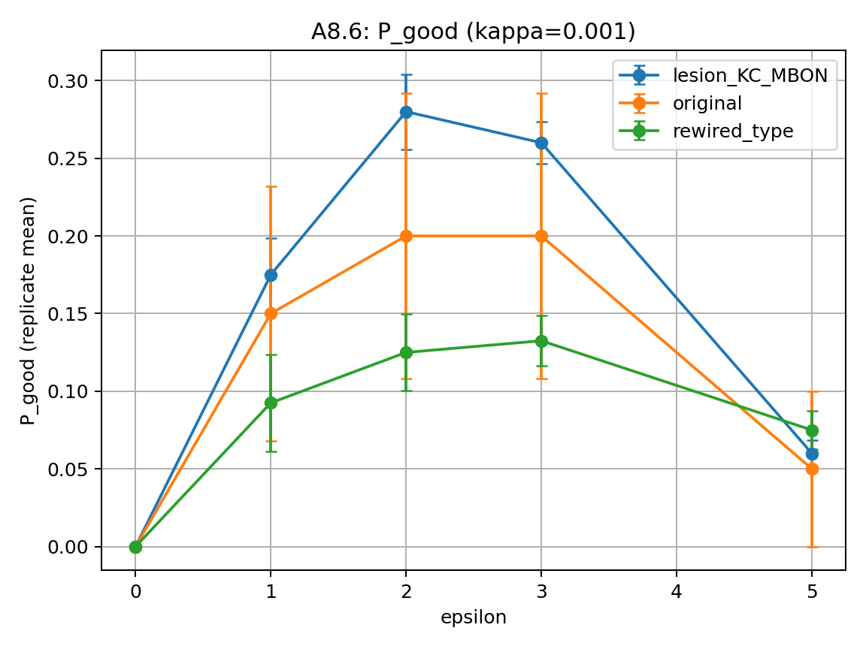

Figure S2. Probability-of-good-run P_good vs disorder ε at κ=1.0 (Drosophila MB).

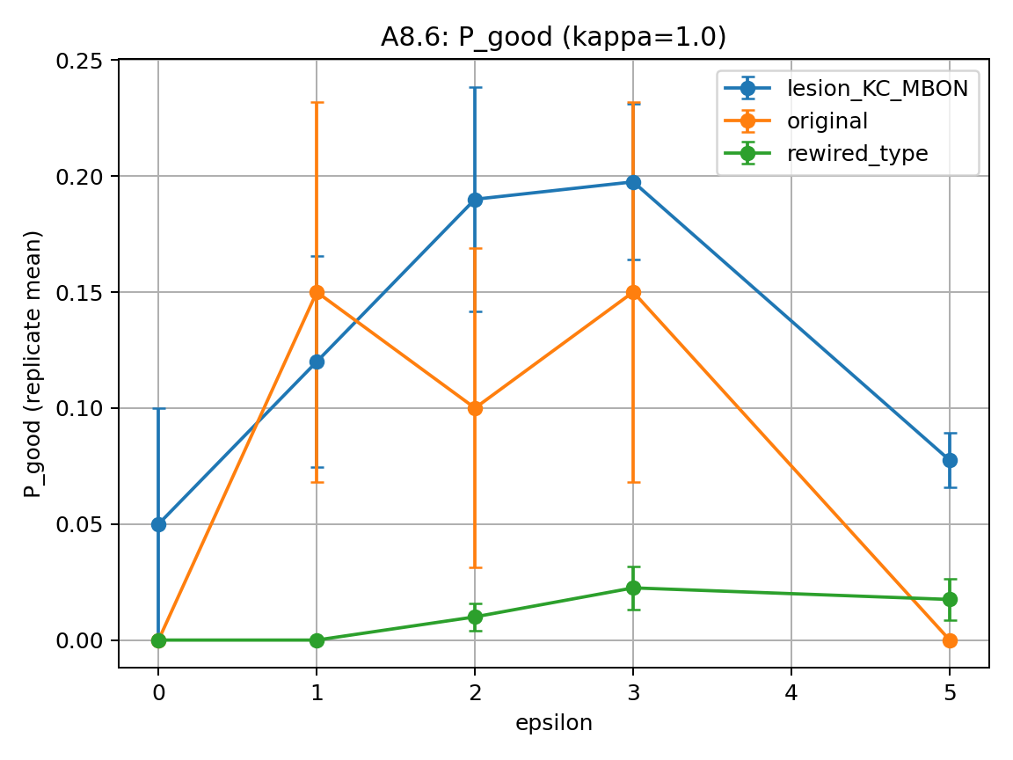

Figure S3. Coverage_end vs disorder ε at κ=0.001 (Drosophila MB).

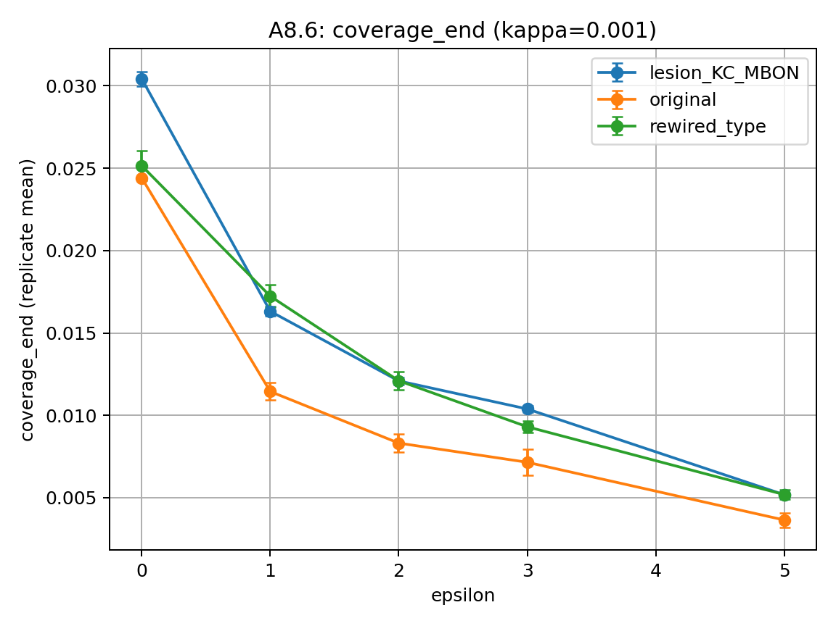

Figure S4. Coverage_end vs disorder ε at κ=1.0 (Drosophila MB).

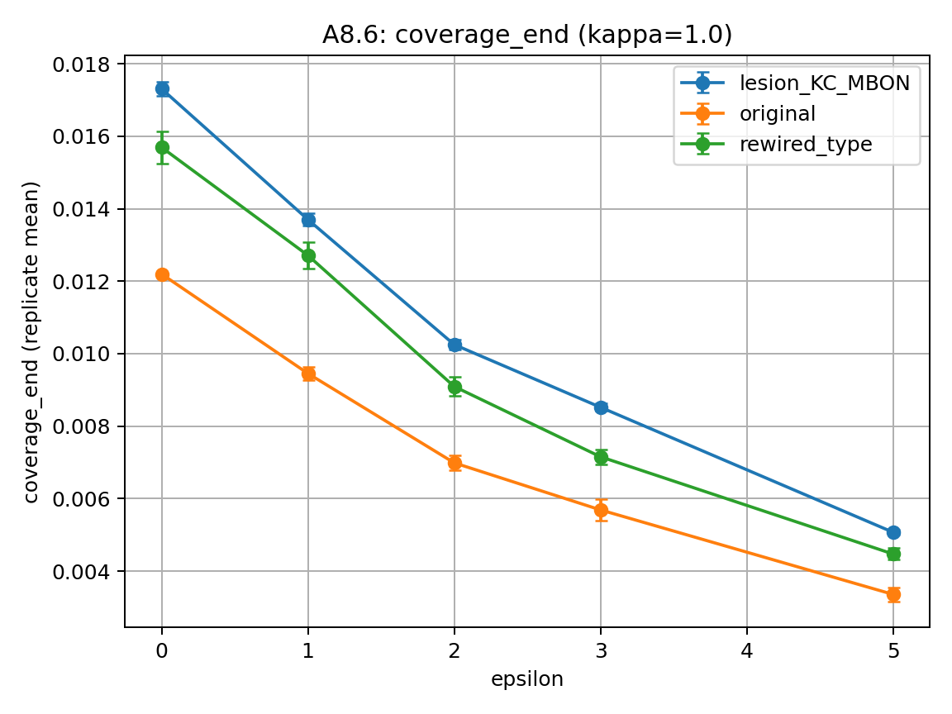

## 4.5. Energy‑aware objectives and information‑per‑cost

Because CRN is motivated by thermodynamic constraints, we evaluate objectives that penalize distractor absorption and incorporate a cost proxy. Figure 4 summarizes two energy‑aware objectives: (A) an information‑per‑cost score that normalizes useful target absorption by an energy proxy, and (B) a Utility objective P_T − λ·P_D. Intermediate disorder can maximize these objectives in partially coherent regimes even when raw coverage declines.

Figure 4. Energy‑aware objectives across disorder ε. (A) InfoPerCost and (B) Utility, comparing GKSL‑based Stage‑I transport to classical baselines (CRW and CRW_thermal). Curves correspond to best‑by‑objective κ for GKSL at each ε (see Methods).

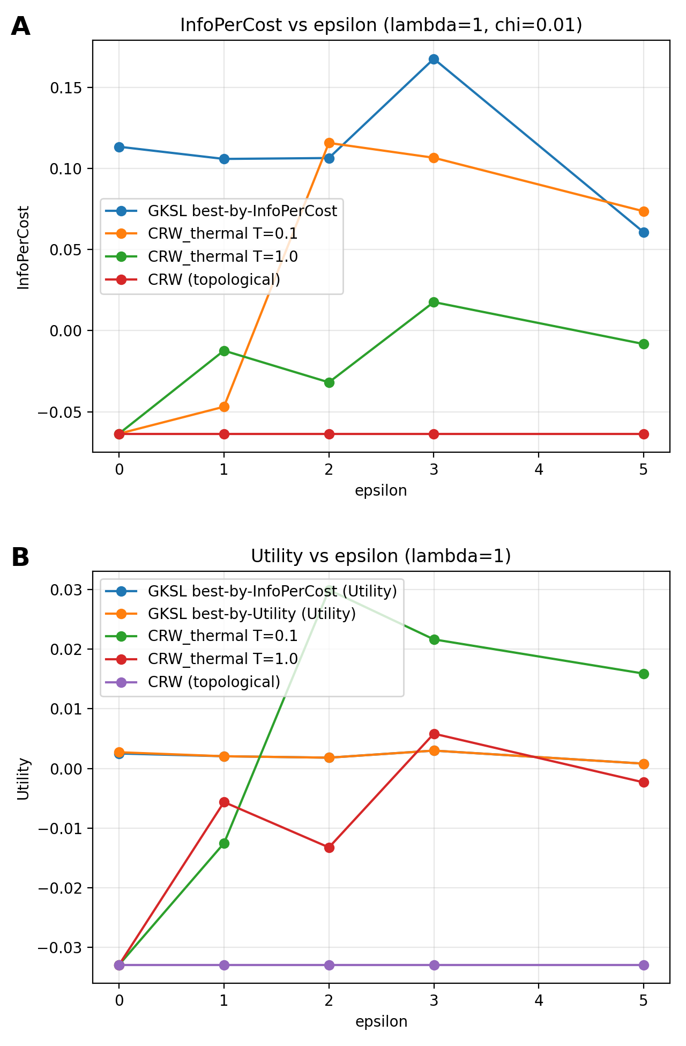

# 5. Falsifiability & Comparison

## 5.1. Competitors & distinctive features

Stochastic resonance (SR) is a classical explanation for inverted‑U performance curves: adding noise can improve detection by helping signals cross thresholds [20]. CRN differs in both mechanism and signature. In SR, noise is typically an additive scalar perturbation that increases threshold crossings. In CRN, the key control is dephasing κ, which regulates interference and localization on a structured graph. Consequently, CRN predicts a topology‑sensitive benefit: degree‑preserving rewiring should strongly attenuate DES while leaving many SR‑type scalar effects unchanged. CRN also predicts boundedness in κ: outside a coherence window, increasing disorder ε is purely destructive.

Predictive coding and Active Inference provide algorithmic accounts of inference under FEP [1,21]. CRN addresses a different level: it proposes a physical ‘engine’ for fast hypothesis search under energy constraints. Stage‑I netting can be interpreted as a fast proposal distribution generator over hypotheses constrained by connectome topology, while Stage‑II corresponds to high‑precision belief commitment and action selection. The distinctive empirical claim is the topology×coherence interaction: if native connectomes encode useful interference structure, then topology‑destroying controls (rewiring, lesions, developmental simplification) should predictably degrade DES.

## 5.2. Falsifiable predictions

P1 (Stress curve): In decision motifs analogous to the mushroom body, moderate metabolic stress (e.g., mild starvation or temperature perturbation) should improve behavioral selectivity relative to both homeostatic and severe‑stress conditions, producing an inverted‑U curve. Effects should be strongest in tasks that tax hypothesis selection rather than long‑term storage.

P2 (Topology dependence): Genetic or developmental manipulations that simplify MB topology (reduced KC connectivity, disrupted compartmentalization) should flatten the stress curve. In silico degree‑preserving rewiring predicts strong attenuation; the biological analogue is reduced motif specificity.

P3 (Anesthesia / dephasing scan): If anesthesia acts as an effective dephasing agent for mesoscale wave dynamics, increasing anesthetic depth should reduce DES and suppress intermediate‑ε benefits. Temperature scans should reveal non‑monotonic ‘windows’ where selectivity peaks, consistent with coherence‑time tuning.

P4 (Noise injection without stress): Weak, uncorrelated subthreshold perturbations (e.g., optogenetic ‘shimmering’) in a non‑stressed preparation should reproduce intermediate‑ε benefits without actual nutrient deprivation, if ε primarily reflects excitability heterogeneity.

P5 (Motif specificity / permeability paradox): In recurrent attractor‑storage motifs, increasing permeability via Stage‑I‑like dynamics should increase false positives. Therefore, the direction of the stress effect should depend on circuit class: search‑and‑route motifs show DES, storage motifs show permeability‑paradox degradation.

Each prediction is falsifiable: absence of an inverted‑U in appropriate decision motifs, lack of topology sensitivity, or monotone effects of anesthetic/temperature scans would jointly undermine the CRN architectural claim.

# 6. Discussion & Conclusion

Taken together, the simulations support an architectural conclusion: a transient wave‑like Stage‑I can provide a thermodynamic advantage by pruning hypothesis space before costly spiking fixation. On real connectomes this advantage manifests as Disorder‑Enhanced Selectivity under moderate disorder and partial coherence, and depends on native topology. The same permeability that helps routing can be harmful in recurrent memory motifs, motivating a division of labor between transport‑dominant and storage‑dominant circuitry.

Limitations are explicit. The current model uses linear dynamics with absorbing sinks and does not simulate nonlinear spiking gain functions, dendritic nonlinearities, synaptic plasticity, or closed‑loop action. Accordingly, DES should be interpreted as a connectome‑level routing/selection effect, not as a complete theory of cognition. A next step is to couple Stage‑I outputs to explicit Stage‑II spiking networks and test whether predicted energy savings persist under realistic nonlinearities.

If validated experimentally, CRN provides a concrete bridge between thermodynamic constraints (energy budgets, Landauer‑type bounds), inference‑centric theories (FEP/Active Inference), and connectome topology. It also offers a neuromorphic design principle: combine low‑cost analog/wave pre‑selection with high‑precision digital/spiking commitment.

# Data and Code Availability

All scripts, processed CSV tables, and figure‑generation code corresponding to this manuscript are included in the accompanying bundle. Raw connectome sources are cited below.

# References

[1] Friston K. The free‑energy principle: a unified brain theory? Nat Rev Neurosci. 2010;11(2):127–138. doi:10.1038/nrn2787.

[2] Lennie P. The cost of cortical computation. Curr Biol. 2003;13(6):493–497. doi:10.1016/S0960-9822(03)00135-0.

[3] Attwell D, Laughlin SB. An energy budget for signaling in the grey matter of the brain. J Cereb Blood Flow Metab. 2001;21(10):1133–1145. doi:10.1097/00004647-200110000-00001.

[4] Landauer R. Irreversibility and heat generation in the computing process. IBM J Res Dev. 1961;5(3):183–191. doi:10.1147/rd.53.0183.

[5] Hopfield JJ. Neural networks and physical systems with emergent collective computational abilities. Proc Natl Acad Sci USA. 1982;79(8):2554–2558. doi:10.1073/pnas.79.8.2554.

[6] Anderson PW. Absence of diffusion in certain random lattices. Phys Rev. 1958;109(5):1492–1505. doi:10.1103/PhysRev.109.1492.

[7] Plenio MB, Huelga SF. Dephasing‑assisted transport: quantum networks and biomolecules. New J Phys. 2008;10:113019. doi:10.1088/1367-2630/10/11/113019.

[8] Caruso F, Chin AW, Datta A, Huelga SF, Plenio MB. Highly efficient energy excitation transfer in light‑harvesting complexes: the fundamental role of noise‑assisted transport. J Chem Phys. 2009;131:105106. doi:10.1063/1.3213548.

[9] Rebentrost P, Mohseni M, Aspuru‑Guzik A. Role of quantum coherence and environmental fluctuations in chromophoric energy transport. J Phys Chem B. 2009;113(29):9942–9947. doi:10.1021/jp901159h.

[10] Engel GS, Calhoun TR, Read EL, et al. Evidence for wavelike energy transfer through quantum coherence in photosynthetic systems. Nature. 2007;446:782–786. doi:10.1038/nature05678.

[11] Gorini V, Kossakowski A, Sudarshan ECG. Completely positive dynamical semigroups of N‑level systems. J Math Phys. 1976;17(5):821–825. doi:10.1063/1.522979.

[12] Lindblad G. On the generators of quantum dynamical semigroups. Commun Math Phys. 1976;48:119–130. doi:10.1007/BF01608499.

[13] Whitfield JD, Rodríguez‑Rosario CA, Aspuru‑Guzik A. Quantum stochastic walks: a generalization of classical random walks and quantum walks. Phys Rev A. 2010;81:022323. doi:10.1103/PhysRevA.81.022323.

[14] Kendon V. Decoherence in quantum walks — a review. Math Struct Comput Sci. 2007;17(6):1169–1220. doi:10.1017/S0960129507006354.

[15] Yerkes RM, Dodson JD. The relation of strength of stimulus to rapidity of habit‑formation. J Comp Neurol Psychol. 1908;18:459–482.

[16] Varshney LR, Chen BL, Paniagua E, Hall DH, Chklovskii DB. Structural properties of the Caenorhabditis elegans neuronal network. PLoS Comput Biol. 2011;7(2):e1001066. doi:10.1371/journal.pcbi.1001066.

[17] Anokhin KV. The Cognitome: Seeking the Fundamental Neuroscience of a Theory of Consciousness. Neurosci Behav Physiol. 2021;51:915–937. doi:10.1007/s11055-021-01149-4.

[18] Winding M, Pedigo BD, Barnes CL, et al. The connectome of an insect brain. Science. 2023;379(6636):eadd9330. doi:10.1126/science.add9330.

[19] Maslov S, Sneppen K. Specificity and stability in topology of protein networks. Science. 2002;296(5569):910–913. doi:10.1126/science.1065103.

[20] Gammaitoni L, Hänggi P, Jung P, Marchesoni F. Stochastic resonance. Rev Mod Phys. 1998;70(1):223–287. doi:10.1103/RevModPhys.70.223.

[21] Rao RPN, Ballard DH. Predictive coding in the visual cortex: a functional interpretation of some extra‑classical receptive‑field effects. Nat Neurosci. 1999;2:79–87. doi:10.1038/4580.

[22] Oh SW, Harris JA, Ng L, et al. A mesoscale connectome of the mouse brain. Nature. 2014;508:207–214. doi:10.1038/nature13186.